Paula De Francisco Pérez  Brand & Marketing · F&B · Events, Influencer & CRM  Dubai, UAE | +971 50 386 3656 | paulich98@hotmail.com  linkedin.com/in/paula-de-francisco-perez-92a13119a  Portfolio: paula-de-francisco.vercel.app  Nationality: Spanish | UAE Employment Visa (employer-sponsored) | 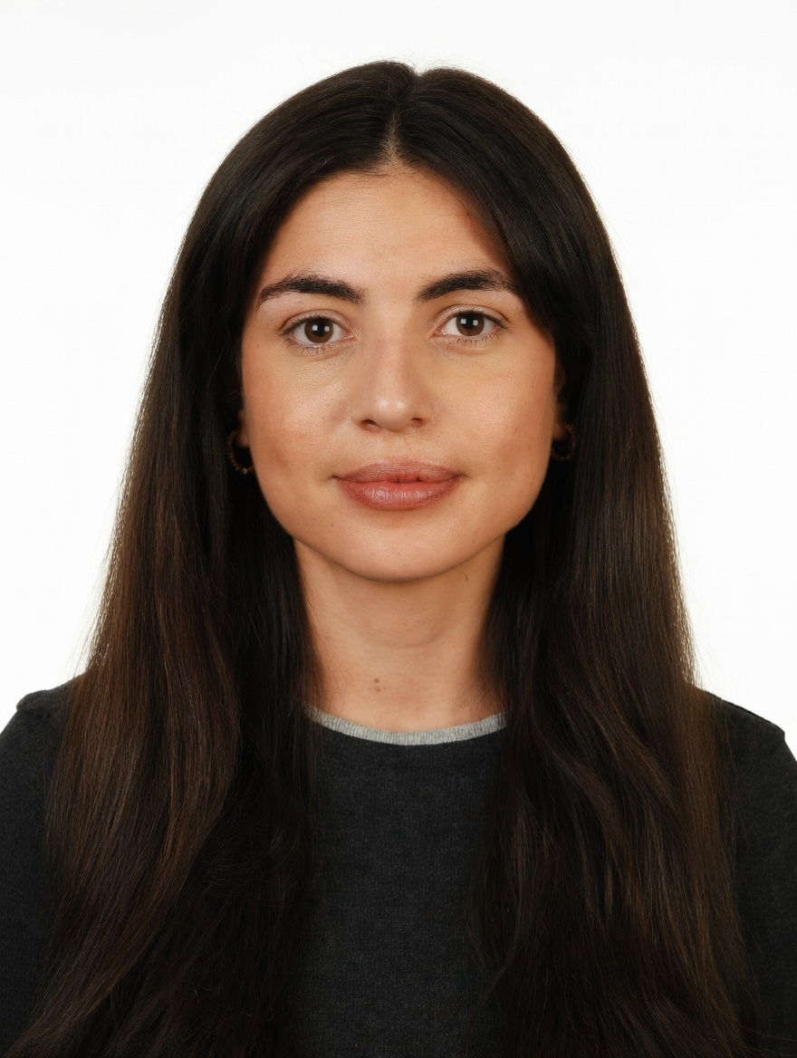
PROFESSIONAL SUMMARY

Brand & Marketing Manager with 5 years across F&B, beauty and e-commerce. At DoFreeze in Dubai, runs the marketing calendar for 7 F&B brands with a team of two: campaigns, influencer gifting, events and partnerships, CRM and paid social. Previously grew 42 beauty and fragrance brands +30% GMV QoQ at Alibaba's Miravia and co-managed KFC, Taco Bell and Vicio at Glovo.
WORK EXPERIENCE

Brand & Marketing Manager | Oct 2025 – Present
DoFreeze LLC · UAE F&B group | 7 brands incl. Befit, Eurocake, SMASH | sold across the GCC and 50+ countries · Dubai, UAE
• Run the marketing calendar for 7 F&B brands with a team of two (designer, social media exec): seasonal campaigns (Ramadan, New Year, back to school), 6 launches, creative briefs and sign-off on all content
• Built influencer gifting and seeding from zero: 103 creator activations over 3 waves at AED 81 per content piece (market AED 1,000–3,500); negotiated −30% and audited the agency's reporting
• Events and activations: Saudi Food Show 2026 (Jeddah), a Sun & Sand Sports x Fabletics yoga session that led to a listing proposal, kids sports-camp sampling with QR-tracked codes, running and padel clubs
• Partnerships measured on sales: a purchase-to-enter talabat giveaway lifted SMASH daily sales +165% vs +4.7% for a control brand; Befit x Noon 'New Year, New Me' added 4,176 incremental units
• CRM and digital: segmented a 16K email base, added a 30-day replenishment flow and reviews (web orders +86%); Meta Advantage+ retargeting at 3.7x ROAS in week one
• Manage agencies and suppliers (alist, Yamammi, BixGrow, Lovable for the website) within budget; built a Claude-based system automating planning, content and reporting (~40% less manual work)
Key Account Manager – Beauty, Fragrances & Fashion | Nov 2023 – Oct 2025
Miravia & AliExpress (Alibaba Group) · Marketplace | Beauty & Health department · Madrid, Spain
• Grew 42 beauty and fragrance brands (incl. L'Oréal Paris, Maybelline, NYX, Redken, KIKO Milano) +30% GMV QoQ through pricing, promotions and on-site visibility; worked with marketing, product and ops
• Created the Beauty Club loyalty programme and Hot on Social, a monthly trend showcase; grew Arabian perfume into a top-growing sub-category; owned Flash Sales, reporting to the CEO
Account Manager – XL Accounts | Sep 2022 – Nov 2023
Glovo · Food delivery app | 10K+ employees · Madrid, Spain
• Co-managed 5 XL restaurant accounts (KFC, Taco Bell, Vicio): promotions, in-app visibility; kitchen visits to cut prep times
Early Career | 2018 – 2022
Mondelez International · Massimo Dutti (Inditex) · Global FMCG | Premium fashion retail · Madrid, Spain
• Category Planning Trainee, Mondelez (Aug 2021 – Aug 2022): promo-effectiveness analysis and NPD support
• Sales Associate, Massimo Dutti (Jun 2018 – Jun 2019): premium customer experience on the Las Rozas Village store floor
CORE SKILLS & TOOLS

Brand & Campaigns | marketing calendar, integrated campaigns, creative briefs, content, launches, brand standards
Digital & CRM | Meta Ads, Google Ads, Instagram, TikTok, email & segmentation, Shopify, website content
Events & Partners | events & activations, partnerships, influencer & gifting, sampling, agency & supplier management
Data & Analytics | campaign reporting, ROI, ROAS, incremental uplift vs control, Excel (Expert), Looker, Power BI
Tools & AI | Claude (AI automation), ChatGPT, Canva, Photoshop, Illustrator, Notion
EDUCATION

Bachelor's in Business Administration — CUNEF Universidad, Madrid | 2016 – 2020
Specialisation: E-Commerce · Fashion Industry · Thesis on e-commerce in fashion retail (9.5/10)
Google E-Commerce Certificate · Google Digital Marketing Certificate
LANGUAGES

Spanish | Native | English | Professional C1

